Noah M. Jorgenson

Lab 7

1. TATA BINDING PROTEIN (TBP)/DNA COMPLEX
2. The resolution is 2.90, they used the Uppsala Electron-Density Server to evaluate the electron density of the crystal structures.
3. –
4. Chain A is longer and makes up all of the ribbon like features, while chains B and C are identical and are the sort of semi-helix structure which appear to be connected by the blue paddle-like features. The paddles are thos matching nucleotides I think. Chains B and C are identical but are ‘palindromes’ so their reverse complement of the nucleotides is the reverse of the chain sequence itself, so since they are positioned one going one way the other going the other way, the nucleotides match up (C’s to G’s and T’s to A’s) and so I assume the paddles are just the nucleotide representation or whatever is actually forming that pair.
5. –
6. –
7. 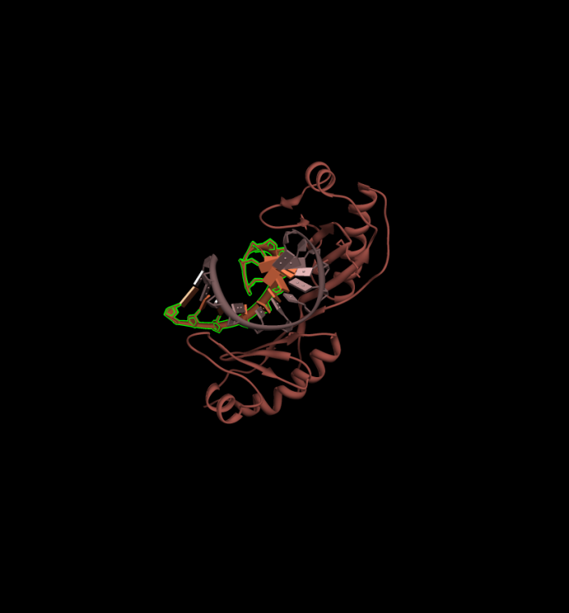
8. The sub_seq[::-1] returns the list starting from the last element (-1 denotes the last element in the list) and then goes to the ‘other side of the colon’. So basically, it returns the reverse of the list.

8 CATG

39 CGCG

40 GCGC

65 CGCG

68 GATC

74 ACGT

87 ACGT

92 ACGT

102 ACGT

121 TTAA

127 GTAC

The longest palindrome was ‘GTTAAC’ as seen below, at a length of 6 nucleotides

Palindromes

2 {128: 'TA', 130: 'CG', 4: 'AT', 6: 'GC', 9: 'AT', 132: 'AT', 12: 'AT', 15: 'AT', 18: 'AT', 20: 'TA', 21: 'AT', 23: 'TA', 25: 'CG', 39: 'CG', 40: 'GC', 41: 'CG', 42: 'GC', 48: 'CG', 50: 'GC', 51: 'CG', 53: 'GC', 54: 'CG', 57: 'AT', 61: 'AT', 63: 'GC', 65: 'CG', 66: 'GC', 67: 'CG', 69: 'AT', 75: 'CG', 82: 'CG', 83: 'GC', 88: 'CG', 90: 'TA', 93: 'CG', 95: 'TA', 98: 'CG', 99: 'GC', 103: 'CG', 105: 'TA', 110: 'TA', 113: 'CG', 122: 'TA', 125: 'CG'}

4 {65: 'CGCG', 68: 'GATC', 102: 'ACGT', 39: 'CGCG', 8: 'CATG', 74: 'ACGT', 40: 'GCGC', 87: 'ACGT', 121: 'TTAA', 92: 'ACGT', 127: 'GTAC'}

6 {120: 'GTTAAC'}

8 {}

For the first chain C DNA sequence I got the following dna-amino acid pairs:

Nearest residues for DNA sequence chain

113 [ 193. 13.15639019]

114 [ 192. 8.5408659]

115 [ 192. 5.18368816]

116 [ 193. 5.81409788]

117 [ 218. 6.7746048]

118 [ 219. 4.9481802]

119 [ 163. 5.54795408]

120 [ 257. 5.93283653]

121 [ 305. 7.01050329]

122 [ 285. 5.98133802]

123 [ 285. 6.516572]

124 [ 282. 8.40169716]

For the first chain B DNA sequence I got the following dna-amino acid pairs:

101 [ 284. 13.96583652]

102 [ 283. 10.06281567]

103 [ 284. 5.53119469]

104 [ 284. 6.1560297]

105 [ 297. 7.18616962]

106 [ 310. 4.15313911]

107 [ 253. 5.3505497]

108 [ 216. 6.36898232]

109 [ 216. 5.99359369]

110 [ 194. 6.30085897]

111 [ 194. 8.89234924]

112 [ 191. 12.26055908]

Here is an image showing the 1TGH structure with the DNA-Protein contact residue pairs in matching colors.

***Note****: Some pairs overlapped in their ‘closest residue’ value so in some cases there is not a corresponding color since a later pair overwrote its value.